Helpful Hints for Filling out the TFR Form:

Initial and Extended Attack Dispatches are in Degrees, Decimal, Minutes.
TFR’s are in Degrees, Minutes, Seconds.

To convert Degrees Minutes Seconds to Degrees Decimal Minutes, divide seconds by 60.
Example: 48º 20’30” -> Divide 30 by 60 = .5’ rewrite 48º 20.5’

To convert Decimal Minutes to Degrees Minutes Seconds multiply the hundredths by 60.
Example 48º 20.5’ -> .5 x 60 = 30” rewrite 48º 20’30”

Conversion Chart: Seconds to Hundredths
Second | Hundredth | Second | Hundredth | Second | Hundredth
1 | 0.02 | 21 | 0.35 | 41 | 0.68
2 | 0.03 | 22 | 0.37 | 42 | 0.70
3 | 0.05 | 23 | 0.38 | 43 | 0.72
4 | 0.07 | 24 | 0.40 | 44 | 0.73
5 | 0.08 | 25 | 0.42 | 45 | 0.75
6 | 0.10 | 26 | 0.43 | 46 | 0.77
7 | 0.12 | 27 | 0.45 | 47 | 0.78
8 | 0.13 | 28 | 0.47 | 48 | 0.80
9 | 0.15 | 29 | 0.48 | 49 | 0.82
10 | 0.17 | 30 | 0.50 | 50 | 0.83
11 | 0.18 | 31 | 0.52 | 51 | 0.85
12 | 0.20 | 32 | 0.53 | 52 | 0.87
13 | 0.22 | 33 | 0.55 | 53 | 0.88
14 | 0.23 | 34 | 0.57 | 54 | 0.90
15 | 0.25 | 35 | 0.58 | 55 | 0.92
16 | 0.27 | 36 | 0.60 | 56 | 0.93
17 | 0.28 | 37 | 0.62 | 57 | 0.95
18 | 0.30 | 38 | 0.63 | 58 | 0.97
19 | 0.32 | 39 | 0.65 | 59 | 0.98
20 | 0.33 | 40 | 0.67 | 60 | 1.00

- Zulu/Greenwich Mean Time Conversion Chart (Hint: PDST, add 7 hours to local time. PST, add 8 hours to local time).

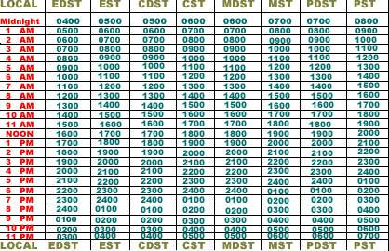

- Mean sea level (MSL) is an average level for the surface of one or more of Earth's oceans from which heights such as elevations may be measured. For the TFR form, calculate 2,000’ above the highest terrain or highest flying aircraft. If not already identified, contact your Air Attack to determine appropriate altitude.

